SWE NEW YORK EINAH REZA PELAEZ MANALO MEMORIAL SCHOLARSHIP
2020 Scholarship Application Form
Please read the below instructions and reach out to Lorraine Herger, lmherger@gmail.com, with questions.

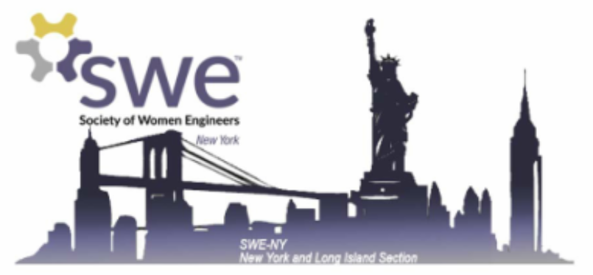
Instructions
Return completed applications to swe.ny.scholarships@gmail.com Completed applications will include the following:
1) A completed online 2020 SWE NY Scholarship Application form, found below.
2) A PDF of your unofficial transcript sent via email to swe.ny.scholarships@gmail.com
3) An letter of recommendation, from a professor, mentor, or (former) employer.
If you've applied to SWE NY Scholarship in previous years, we request you please write unique Short Response Question and Essay prompt responses different from previously submitted applications
Please submit the above items by midnight on April 24, 2020. You will receive a confirmation email when your application is complete.
Please feel free to add pages to this form in order to complete your responses.

Introduction
Although female participation in Science, Technology, Engineering and Math (STEM) fields has increased greatly in the past several decades, females are still a minority in STEM professions. The Society of Women Engineers New York Section (SWE-NY) has an outstanding reputation for supporting female professionals and female students involved in STEM by providing resources to help them succeed. The intent of the scholarships is to reward collegiate females for excelling in the field of engineering and encourage them to continue pursuing their goals.
SWE-NY, in partnership with ASHRAE, will offer multiple scholarships. Recipients will be selected on a point system based on their academic excellence, involvement in activities outside of the classroom, and dedication to STEM fields. Scholarship recipients will also be featured in the SWE-NY Newsletter.

Point Allotment
Academic Success: 20 points
Extracurricular Involvement & Work Experience: 20 points
Short Answers: 25 points
Essay: 35 points
TOTAL: 100 points

Eligibility Requirements
To be eligible, applicants must meet the following qualifications:
1) Be a female enrolled in an ABET accredited engineering school in New York City, Long Island, or the Greater New York Area. A list of ABET accredited schools is available on the SWE-NY website.
2) Be entering your 2nd year, 3rd year or 4th year of collegiate studies or in a Graduate Program in the Fall Semester of 2019. Students entering their 5th year of collegiate studies in the Fall Semester of 2019 enrolled in a co-op program are eligible. Students transferring into an ABET accredited engineering school are eligible upon proof of transfer enrollment and submission of an official transcript from the prior school
3) Be a U.S. Citizen or a U.S. Resident
4) Be a SWE Student Member or ASHRAE member
Contact lmherger@gmail.com with any questions.

Applicant Information
Name (first and last)

Address

City

State and Zip Code

Phone Number

Are you a SWE or ASHRAE member?

SWE Section Name and Code

Educational Information
College or University

Major

How many credits will you have completed at the end of the 2019 - 2020 academic year?
Please enter a number

How many credits are required for graduation?
Please enter a number

What is your GPA?

What is the maximum GPA possible?

Please list any academic honors or awards you have received.

Extra-curricular Activities
Which organizations (including athletics, student clubs and community organizations) have you participated in and what was your role?
For each activity, please list (1) the organization name, (2) your position, and (3) your responsibilities

Work Experience #1
Employer

Position

Dates

Type of Business

Supervisor

Phone Number

Your Duties and Responsibilities

(expand as required for other work experience)

Short Response questions
Please limit your response to each question to no more than 300 words.
If you've applied to SWE NY Scholarship in previous years, we request you please write unique Short Response Questions different from previously submitted applications

Briefly state your educational and career goals.
300 words max

Please state your field of engineering and explain why you chose it for your studies.
300 words max

If you have been involved with the Society of Women Engineers (SWE), how has it helped you or others? If you have not been involved, how do you think you could benefit from SWE?
300 words max

Essay
Please choose ONLY ONE of the questions below and type a response. Please limit your response to no more than 500 words.
If you've applied to SWE NY Scholarship in previous years, we request you please write unique Essay prompt responses different from previously submitted applications

Who or what inspired you to pursue engineering and what do you find most exciting about it?
500 words max. Please choose ONLY ONE essay question to answer.

What past experiences do you think have shaped you the most as a person and why?
500 words max. Please choose ONLY ONE essay question to answer.

After you complete your studies in engineering, what kind of challenges do you foresee as a future engineer and how do you plan to overcome them?
500 words max. Please choose ONLY ONE essay question to answer.

Email your transcript to lmherger@gmail.com and to have your endorser submit a letter of recommendation.

Certification
I believe all of the information provided to be accurate. I hereby apply for a Society of Women Engineers New York Section Collegiate Scholarship. I further certify that I am not receiving full funding for my education from an employer, any branch of the Armed Services or other organization.
I agree

I disagree

Signature_______________________________________ Date___________________________________

