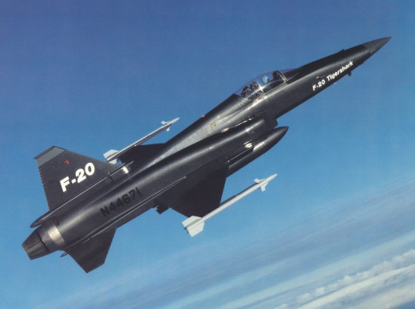

AIAA/AFA/ASME/ISA Joint Meeting

Thursday, October 16, 2014

Burt Dicht,
IEEE Director of University Programs

“Project Terminated – Famous Military Aircraft Cancelations of the Cold War.”

Location: Bethpage Public Library
RESERVATIONS REQUIRED
RSVP BY October 15, 2014
to: David Paris at
davidsparis@optonline.net
or (516) 458-8593

47 Powell Avenue
Bethpage, NY 11714

Time: 6:00 PM Social Time
6:30 PM Pizza
7:00 PM Presentation

Cost for Pizza: $5, Members and Guests
Free, for Students

During the Cold War, ten aircraft were designed and prototypes built but never went into production. Many of these aircraft pushed the boundaries of technology but also faced obstacles beyond the designer’s control. Politics, for example. In this presentation, Mr. Dicht will highlight several of these aircraft, touching on the technological challenges involved for each aircraft and the decisions that led to program cancellation. He will also speculate on how these aircraft would have performed if incorporated into operational squadrons. Mr. Dicht relies heavily on Project Terminated, a recent book by Erik Simonsen, but adds his own perspective on the Northrop F-20 Tigershark. He was a senior engineer on the F-20 design team.

Burt Dicht has been a lead engineer for Northrop Grumman and Rockwell Space Transportation Systems Division. He has worked on such projects as the F-5E Tiger II, the F20A Tigershark, the F-18E/F Super Hornet, the YF-23A Advanced Tactical Fighter and the Space Shuttle. He also served on the staff of Congressman Jon Fox. He has a B.S. in Mechanical Engineering and an M.A. in History. He is a member of IEEE, AIAA and an ASME Fellow.

As Director of IEEE University Programs, he is responsible for directing IEEE’s engineering education accreditation activities and for developing programs for faculty and students. Immediately before joining IEEE, Mr. Dicht was the Managing Director of ASME’s Knowledge and Community Sector where he was responsible for directing the staff support for ASME’s sections, student sections and technical divisions.

Directions: The library is west of Route 135 in Bethpage. Take Route 135 to Exit 8, then West on Powell Ave. for about 0.25 miles. The library is on the south side of the street. Park across Powell Ave., opposite the library.

