SWE New York Einah Reza Manalo Pelaez Memorial Scholarship
2023 Scholarship Application Form
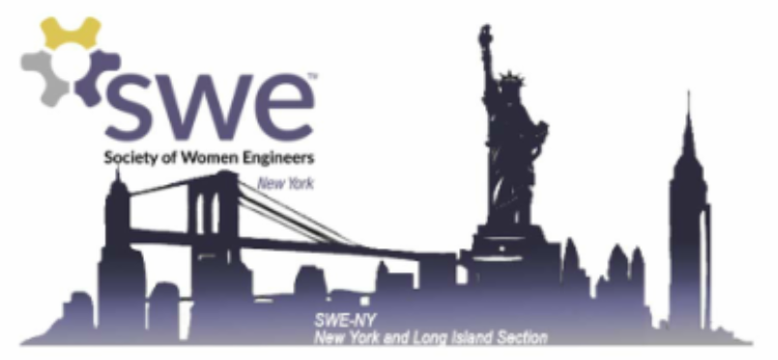
Instructions
Please return completed applications to swe.ny.scholarships@gmail.com, including the following:
1) A completed 2023 SWE New York Scholarship Application form, found below.
2) A PDF of your unofficial transcript.
3) A letter of recommendation from a teacher/professor, advisor, mentor or other professional reference.
Please submit the above items by midnight on April 30th, 2023. You will receive a confirmation email when your application is received.
Please feel free to reach out with any questions!

Helpful Tips
- We have included word limits for your responses, but you may insert additional pages as necessary
- If you have applied to a SWE New York Scholarship in past years, we request that you write unique short response and essay prompt responses from previously submitted applications

Introduction
Although female participation in Science, Technology, Engineering and Math (STEM) fields has increased greatly in the past several decades, females are still a minority in STEM professions. The Society of Women Engineers, New York and Long Island (SWE New York) has an outstanding reputation for supporting female professionals and female students involved in STEM by providing resources to help them succeed. The intent of these scholarships is to encourage young women interested in careers in STEM to continue pursuing their goals as future engineers and leaders.
Recipients will be selected based on the following criteria:
- Academic performance (20%)
- Extracurricular involvement and experience (20%)
- Short answers (25%)
- Essay (35%)
SWE New York will offer at least three (3) scholarships, each in the amount of $1000 or more.
Award recipients will be notified on or before June 15th, 2023.
Eligibility Requirements
To be eligible, applicants must meet the following qualifications:
1) Be a female-identifying student enrolled in an ABET-accredited college or university in New York City, Long Island, or the Greater New York Area. A list of eligible schools is available at newyork.swe.org/2023-scholarship.
2) Be a high school senior or current collegiate enrolled in an engineering program in the fall semester of 2023. Students entering their 5th year of collegiate studies or those who are enrolled in graduate or co-op programs are also eligible. Students transferring into an ABET-accredited college or university are eligible upon proof of transfer enrollment and submission of an official transcript from the prior school.
3) Be a U.S. Citizen or a U.S. Resident.

Applicant Information
Name (first and last):

Address:

City:

State and Zip Code:

Phone Number:

Are you currently a SWE member? (Not required to apply)

If so, please include your SWE Section and Membership ID:

Education:
College or University:

Major:

How many credits will you have completed at the end of the 2022-2023 academic year?

How many credits are required for graduation?

What is your GPA (out of the possible maximum)?

Please list any academic honors or awards you have received.

Extracurricular Activities
Which organizations (including athletics, student clubs and community organizations) have you participated in and what was your role?
For each activity, please list (1) the organization name, (2) your position, and (3) your responsibilities

Work Experience
Employer:
Position:
Dates:
Type of Business:
Supervisor:
Phone Number:
Your Duties and Responsibilities:

Short Response Questions
Please limit your response to each question to no more than 300 words.
1. Briefly state your educational and career goals.

2. Please state your field of engineering and explain why you chose it for your studies.

3. If you have been involved with the Society of Women Engineers (SWE), how has it helped you or others? If you have not been involved, how do you think you could benefit from SWE?

Essay
Please choose ONLY ONE of the questions below and write a response. Please limit your response to no more than 500 words.
What (or who) inspired you to pursue engineering? What do you find most exciting about it?

What past experiences do you think have shaped you most as a person and why?

After you complete your studies, what challenges do you foresee as a future engineer and how do you plan to overcome them?

Certification
By signing below, I certify that the information provided in this application is accurate to the best of my knowledge. I hereby apply for the SWE New York Einah Reza Manalo Pelaez Memorial Scholarship. I further certify that I am not receiving full funding for my education from an employer, any branch of the Armed Services or other organization.

Signature ____________________________________________ Date____________________________

